Krista Lynn Press Kit
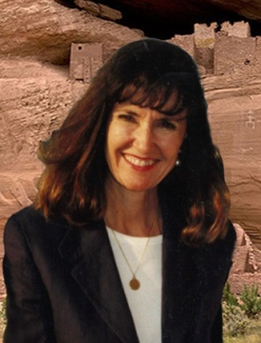
www.kristallynn.com
It’s no mystery why Krista Lynn writes about the high desert of Arizona. She grew up on a gold mine about 60 miles north of Phoenix. The closest neighbor was 6 miles or so down the Agua Fria River, or another 20 miles by dirt road. The magic and spirit of a rugged, isolated landscape where mysteries are carried on the wind, and whispered in your sleep are the multi-colored threads woven into her series of romantic supernatural suspense set in the high desert of Arizona.
Before embarking on the writer’s path, Krista taught physical geography and GIS courses at CSUF and Fresno City College before taking an Academic Coordinator position at UC Davis Cooperative Extension where she built a GIS program to assist agricultural research. She lives in California with her husband and a menagerie of dogs, goats and one spoiled horse while continuing to write the Canyon Trilogy and an anthology of cozy mysteries.
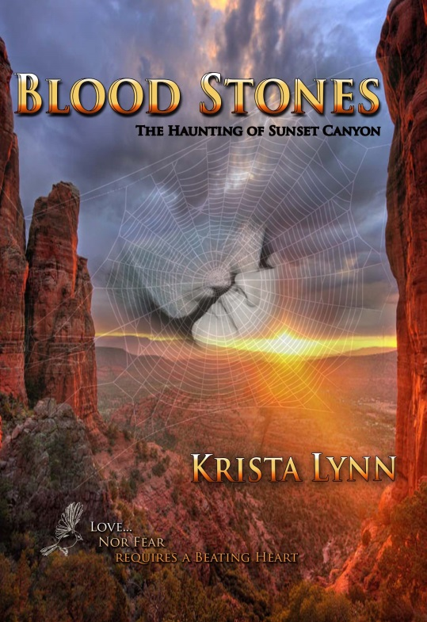
Blood Stones: The Haunting of Sunset Canyon
Within Sunset Canyon, deep in the Arizona desert, the love a young woman feels for her mysterious lover grows deeper every year, though her heart stopped beating over a century ago - stilled by the one she loves. What magic could cause this? What ancient Indian witchcraft could hold her and make her part of The Haunting of Sunset Canyon?
When Darcy Peel left Dry Creek, Arizona, to go to graduate school, she thought she had left for good. She never thought she would come back to the small high-desert community nestled in the shadow of Prospector’s Mountain or that she’d have to go into the legendary red rock gorge known in Indian lore as the “Canyon that Sees the Sun.” But, now she is compelled to return and find her sister who is lost in the canyon—like her father and brother before her.
Research documents and a little leather-covered book that her sister sent before she disappeared, offer clues and brings back memories and dreams of a young woman trapped in the canyon. On the trail to the truth, Darcy meets Alan Brandt, a young deputy with ties to her family’s past and possessing hidden abilities that link him to stories of ghost warriors. Can she trust him to help find her sister as he promises? Or is she being trapped by the mountain’s magic - seduced by her attraction to a man with an uncanny connection to the deadly legends?
Buy Links:
Amazon Barnes and Noble Black Opal Books
Promotional memes
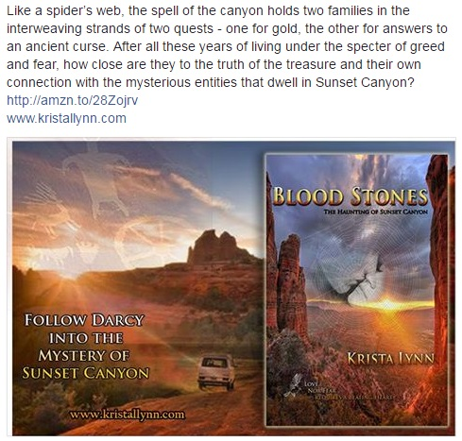
Postcard
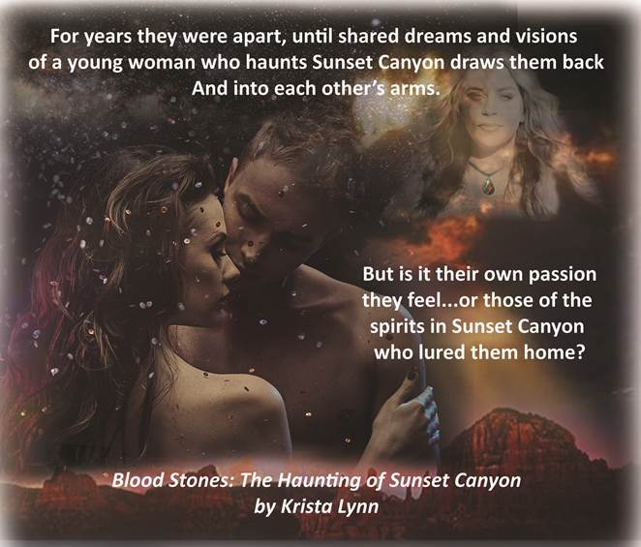
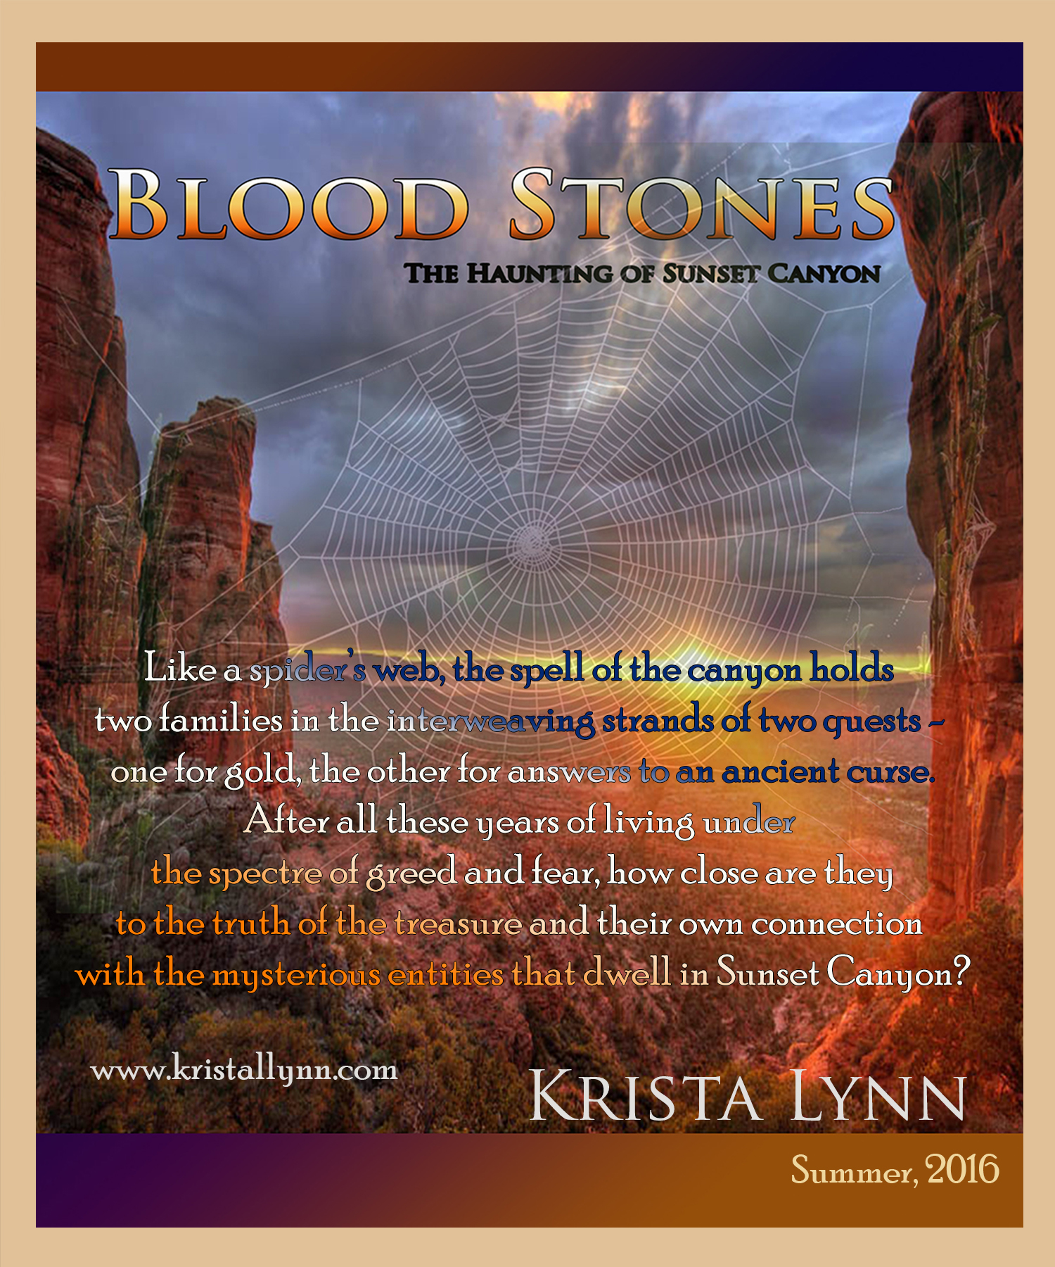
Reviews:
“Wow! That’s exactly what I thought when I finished reading the wonderful book by debut author Krista Lynn, Blood Stones: The Haunting of Sunset Canyon, Volume One. This story line is one that will keep readers engrossed from the first page all the way through to the very last!”
Tracy A. Fisher for Readers’ Favorite
“Blood Stones: The Haunting of Sunset Canyon, Volume 1 is well-written, finely plotted, and a joy to read. I’m looking forward to the next book in this supernatural series. Blood Stones is most highly recommended.”
Jack Magnus for Readers’ Favorite
“Krista Lynn's story of love, lies and mystical happenings in the high desert of Arizona is a journey to more than the mines beyond Phoenix. It's a journey inside Native American folklore, legends and beliefs. The advantage to a longer novel, like Blood Stones is that you really get to know the characters well and if it's written with talent by the time you finish the book, you miss the characters who've kept you company for the last 10 days. Such is the case with Blood Stones and I'm looking forward to the next novel in this fascinating series. Well done, Ms. Lynn.” Kim Hornsby for “Kimmy’s Korner” book reviews.

