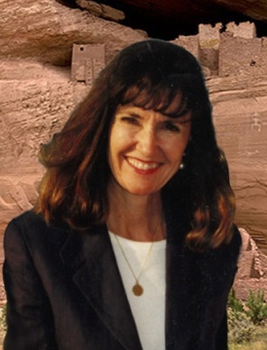
Krista Lynn
Romance – best told with suspense, mystery, and…magic
It’s no mystery why Krista Lynn writes about the high desert of Arizona. She grew up on a gold mine about 60 miles north of Phoenix. The closest neighbor was 6 miles or so down the Agua Fria River, or another 20 miles by dirt road. The magic and spirit of a rugged, isolated landscape where mysteries are carried on the wind, and whispered in your sleep are the multi-colored threads woven into her series of romantic supernatural suspense set in the high desert of Arizona.
Before embarking on the writer’s path, Krista taught physical geography and GIS courses at CSUF and Fresno City College before taking an Academic Coordinator position at UC Davis Cooperative Extension where she built a GIS program to assist agricultural research. She lives in California with her husband and a menagerie of dogs, goats and one spoiled horse while continuing to write the Canyon Trilogy and an anthology of cozy mysteries. www.kristallynn.com
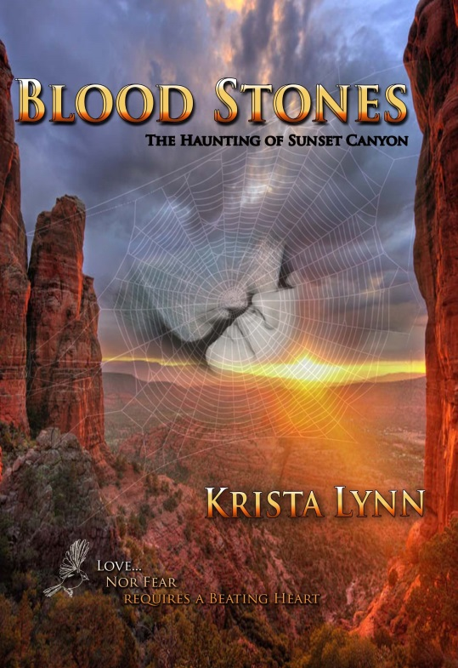
Blood Stones: The Haunting of Sunset Canyon
Deep in the Arizona desert, the love a young woman feels for her mysterious Indian lover grows deeper every year, though her heart stopped beating over a century ago—stilled by the one she loves. What magic could cause this? What ancient Native American witchcraft could hold her spirit captive and make her part of The Haunting of Sunset Canyon? Could the legends of ghost warriors who guard the treasure of the Lost Blood Stones Mine be true?
When Darcy Peel left Dry Creek, Arizona, to go to graduate school, she thought she had left for good. She never imagined she would come back to the small community nestled in the shadow of Prospector’s Mountain. But now she is compelled to return and find her sister who is lost in the red gorge canyon. On her trail to the truth, Darcy meets Alan Brandt, a young deputy who possesses hidden abilities that link him to stories of ghost warriors. Can she trust him to help find her sister as he promises? Or is she being trapped by the canyon’s magic—seduced by her attraction to a man with an uncanny connection to the deadly legends?
Buy Links: http://amzn.to/28Zojrv
Social Links: Facebook Writer’s Page
Twitter Goodreads
“Wow! That’s exactly what I thought when I finished reading the wonderful book by debut author Krista Lynn, Blood Stones: The Haunting of Sunset Canyon, Volume One. This story line is one that will keep readers engrossed from the first page all the way through to the very last!”
Tracy A. Fisher for Readers’ Favorite

Reviews:
“Wow! That’s exactly what I thought when I finished reading the wonderful book by debut author Krista Lynn, Blood Stones: The Haunting of Sunset Canyon, Volume One. This story line is one that will keep readers engrossed from the first page all the way through to the very last!”
Tracy A. Fisher for Readers’ Favorite
“Blood Stones: The Haunting of Sunset Canyon, Volume 1 is well-written, finely plotted, and a joy to read. I’m looking forward to the next book in this supernatural series. Blood Stones is most highly recommended.”
Jack Magnus for Readers’ Favorite
“Krista Lynn's story of love, lies and mystical happenings in the high desert of Arizona is a journey to more than the mines beyond Phoenix. It's a journey inside Native American folklore, legends and beliefs. The advantage to a longer novel, like Blood Stones is that you really get to know the characters well and if it's written with talent by the time you finish the book, you miss the characters who've kept you company for the last 10 days. Such is the case with Blood Stones and I'm looking forward to the next novel in this fascinating series. Well done, Ms. Lynn.” Kim Hornsby for “Kimmy’s Korner” book reviews.

